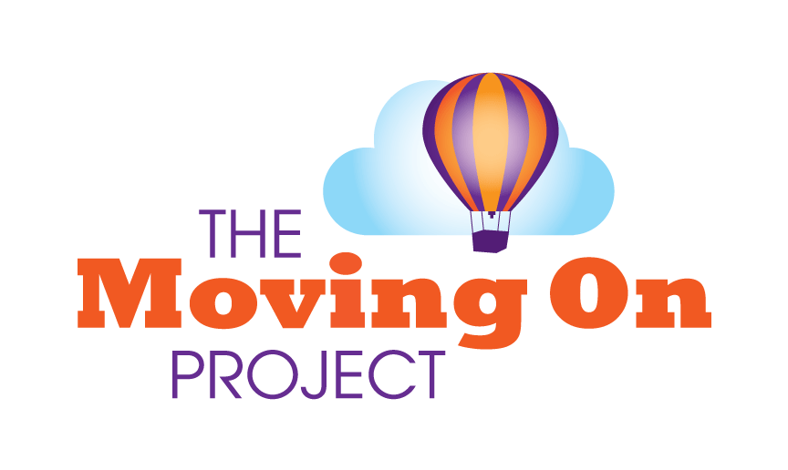

APPLICATION FOR COUNSELLING VOLUNTEERING

Please complete this form in type or black ink & return to info@the-mop.org

Or post to Moving on Project, X-Perience Youth Centre, Trinity Street, Fareham PO16 7SJ
Please note - we cannot accept enquiries about counselling volunteering without a completed application form.

Voluntary post (s) applied for: Counsellor Date of application: ……/……/……
PERSONAL DETAILS
Please ensure you fill out every section – incomplete applications cannot be considered
SURNAME……………………………............................  FIRST NAMES…………………………..........................  ADDRESS  POST CODE……………………………. | TITLE…………… (Mr, Ms, etc.)  Date of Birth :  TELEPHONE NOS:  HOME………………………………….  WORK………………………………….  MOBILE………………………………..  Email..................................................

Would you describe your ethnicity as -
 | Asian British |  | Black British |  | White British
 | Asian Indian |  | Black African |  | White East European
 | Asian Bangladeshi |  | Black Caribbean |  | White West European
 | Asian Pakistani |  | Black other |  | White other
 | Asian other
 |  |  | Mixed race |  | Other

Additional information:
 | No | Yes* | If yes* please give details
Do you have a disability?
Are you currently in Employment?
Are you currently a full or part time student?
Are you currently volunteering anywhere else?
Where/how did you find out about this opportunity :-

How much time are you able to offer the Moving on Project? (please highlight)
Mon morning / afternoon / evening; Tues morning / afternoon / evening; Wed morning / afternoon / evening; Thurs morning / afternoon / evening; Fri morning / afternoon / evening;
Sat – morning / afternoon / evening; Sun morning / afternoon / evening.

Training relevant to your application (Please outline what course you are on and where you are studying. We are able to consider applicants qualified to Diploma or degree level, or at a minimum in the second year of their Diploma. Please contact the Counselling Manager for further information).

School/ College/University | Subjects studied | Qualification & Grade | Dates  From/To

Employment history:
Please include all paid employment and account for any periods with no paid employment e.g. voluntary work, travelling, training, family commitments.

Employment, Volunteering, Travelling, Training, Family… | Dates  From To

Please give details (paid/unpaid) of any previous experience working with children and/or young people: Include details of any training courses attended (i.e. First Aid, computer…), voluntary work undertaken.

(Continue on a separate sheet if necessary).

REFERENCES
The Moving on Project is an organisation that adopts a safer recruitment process in order to safeguard the children and young people who use our service.
Please give contact details for two referees, one of which ideally should know / have known you in an official capacity (i.e. employer, tutor...)
Please ensure none of the referees resides at the same address as you, are related to you or are personal friends. You may wish to ask a tutor or clinical supervisor to supply a reference.
Referees must live within the United Kingdom and must have known you for at least 2 years.

Reference One
Name:

Relationship: your tutor/manager/employer/clinical supervisor etc...
Address:

Postcode:
Telephone:
Email:

Reference Two

Name:

Relationship: your tutor/manager/employer/clinical supervisor etc...
Address:

Postcode:
Telephone:
Email:

MISCELLANEOUS

Do you hold a full U.K. driving license Yes / No

Do you own a car? Yes / No

Declaration – please read carefully

PERSONAL DECLARATIONS
The position for which you are applying involves contact with children. Do you have any convictions, cautions, reprimands or final warnings that are not "protected" as defined by the Rehabilitation of Offenders Act 1974 (Exceptions) Order 1975 (as amended in 2013) Yes / No

If yes, please give details on a separate sheet and attach it to this form in a sealed envelope marked “Confidential Disclosure”.

I understand that my acceptance as a Volunteer would depend upon the completion of a satisfactory enhanced DBS Disclose (please tick) Yes / No
I understand that my acceptance as a Volunteer would depend upon the Moving on Project receiving TWO satisfactory references (please tick) Yes / No
For the purposes of the Data Protection Act 1998, I consent to the information contained in this form, and any information received by or on behalf of the Moving on Project relating to the subject matter of this form, being processed by them in administering the recruitment process. (please tick) Yes / No
I declare that the information I have given on this form is complete and accurate and that I am not barred or disqualified from working with children nor subject to any sanctions or conditions on my employment imposed by the Independent Safeguarding Authority, the Secretary of State or a regulatory body. (please tick) Yes / No
I understand that to knowingly give false information, or to omit any relevant information, could result in the withdrawal of any offer of a voluntary role and possible criminal prosecution. (please tick) Yes / No

- All Candidates applying for volunteering via email will be required to sign & date this form if invited to attend interview

Signed: ………………………………………………………… Date: .....................................

I certify that the information given above is to the best of my knowledge correct, and if I am appointed, personal information about me may be computerised for Personnel/employee administration purposes including analysis for management purposes and statutory returns.

Signed………………………………………………….Date…………………………….

Please ensure you have included your personal statement

All Candidates applying for volunteering via email will be required to sign & date this form if invited to attend interview
Volunteering for the Moving on Project - Personal Statement

Name …………………………………………………….

Tell us your reasons for wanting to be a counsellor, and why you are interested in counselling young people at the Moving on Project. Tell us about your experiences of personal therapy – have you had any? Are you still having it? How long have you been in therapy?
What do you think you can offer the Moving on Project? What do you think the Moving on Project can offer you? What are you interests and/or hobbies?
Please tell us as much about yourself and your reasons for wanting to get involved.
(Continue on a separate sheet if necessary).

